**1976/77**

**North Bucks Challenge Trophy WINNERS**

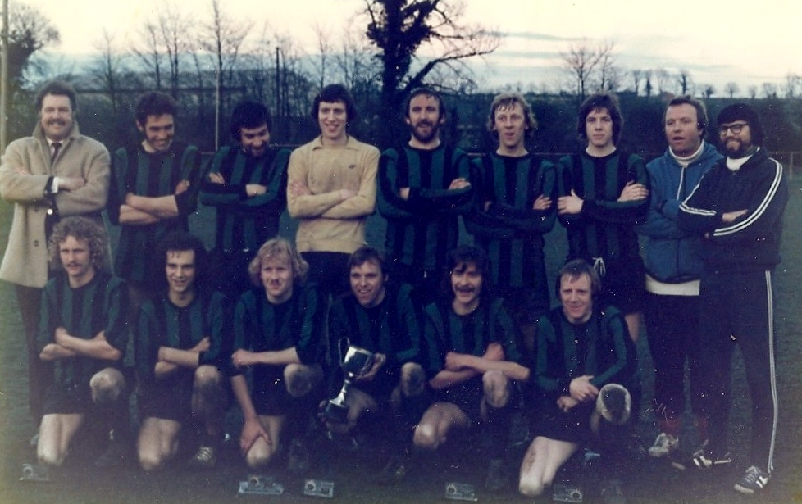

BACK ROW L/R FRONT ROW L/R

Norman Blencow - Chairman Martin Howes

Colin Wait Stuart Chappell

John Allen Nick Franklin

Graham Trevitt Wilf Wilkins

Mick Shipway Pat Lawrence

Andy Wilkins Geoff Johnson

Pat O'Driscoll

Gerald Twynham - Manager

Mick Dale - Secretary